**Exploratory Analysis of Rainfall Data in India for Agriculture**

**Submitted by**

**L.Hirithik kalin**

**B.Dineshmani**

**S.Mohammed Baseer**

**N.Sakthi Saravanan**

**TEAM ID - PNT2022TMID18172**

**Department of**

**Electronics And Communication Engineering**

**Mepco Schlenk Engineering College**

**Institution Mentor:** Amrutha E

**Industrial Mentor:** Lalitha Gayathri

# INTRODUCTION

* 1. Project Overview
  2. Purpose

# LITERATURE SURVEY

* 1. Existing problem
  2. References
  3. Problem Statement Definition

# IDEATION & PROPOSED SOLUTION

* 1. Empathy Map Canvas
  2. Ideation & Brainstorming
  3. Proposed Solution
  4. Problem Solution fit

# REQUIREMENT ANALYSIS

* 1. Functional requirement
  2. Non-Functional requirements

# PROJECT DESIGN

* 1. Data Flow Diagrams
  2. Solution & Technical Architecture
  3. User Stories

# PROJECT PLANNING & SCHEDULING

* 1. Sprint Planning & Estimation
  2. Sprint Delivery Schedule
  3. Reports from JIRA

# CODING & SOLUTIONING (Explain the features added in the project along with code)

* 1. Feature 1
  2. Feature 2
  3. Database Schema (if Applicable)

# TESTING

* 1. Test Cases
  2. User Acceptance Testing

# RESULTS

* 1. Performance Metrics

# ADVANTAGES & DISADVANTAGES

1. **CONCLUSION**

# FUTURE SCOPE

1. **APPENDIX**

Source Code

GitHub & Project Demo Link

# INTRODUCTION:

* 1. **Project Overview:**

Predicting weather events to stop loss of life to humans and the environment due to changing climatic conditions and irregular weather patterns is a critical issue facing humanity. Since there have been significant climatic changes in recent years, appropriate preventive actions are required. Floods may occur as a result of heavy rain. Flash floods can be disastrous. Disasters are occurring more frequently, more intensely, and with greater magnitude due to climate change. As a result, more people are dying and getting hurt, as well as more property and money is being lost. According to the UN Office for Disaster Risk Reduction, weather-related phenomena like heatwaves, storms, floods, and droughts have been responsible for 90% of severe disasters during the past 20 years (UNISDR). Natural disasters are happening more frequently and with greater force.an evacuation area nearby by performing an exploratory analysis of the data collected.

# Purpose

To design a disaster management system by forecasting a flood event to control flood risk by recommending an evacuation area from flood hazard areas which ultimately helps to manage the environment and water resource system.This also serves a purpose of the Early warning system by training a model and selecting the best prediction algorithm among the classifiers.The occurrence of flash floods can cause catastrophic damage to the society. They first mainly affect the people living near to the riverbeds.Evacuating them from the hazard areas and providing them the shelter they needed.With the irregular change in climate patterns, it's been difficult to predict the occurrence of floods using traditional methods leading to massive destruction. Thus to cope with flash floods and to handle critical situations new methodologies are invented to overcome such difficulties.

Technology has to be more aware to reduce the loss that a flash flood would make. In the modernizing era, it's made even easier to predict the occurrence of floods and recommend nearby evacuation areas. Hazard areas that are prone to destruction and devastating loss are monitored regularly and the rainfall readings are collected, integrated from multiple resources, curated, mined, analyzed and prediction is done over patterns.

**2.LITERATURE SURVEY**

* Xiaobo Zhang;Sachi Nandan Mohanty;Ajaya Kumar Parida;Subhendu Kumar Pani;Bin Dong;Xiaochun Cheng. **Annual and Non-Monsoon Rainfall Prediction Modelling Using SVR-MLP: An Empirical Study From Odisha. (IEEE)(2020)**
* Shilpa Manandhar;Soumyabrata Dev;Yee Hui Lee;Yu Song Meng;Stefan Winkler **A Data-Driven Approach for Accurate Rainfall Prediction.** (IEEE)(2019)
* Nana Kofi Ahoi Appiah-Badu;Yaw Marfo Missah;Leonard K. Amekudzi;Najim Ussiph;Twum Frimpong;Emmanuel Ahene **Rainfall Prediction Using Machine Learning Algorithms for the Various Ecological Zones of Ghana**.(IEEE)(2021)
* Deepali Patil Shree L.R.**Rainfall Prediction using Linear approach & Neural Networks and Crop Recommendation based on DecisionTree**.(IEEE)(2020)
* A. Haidar, B. Verma.**Monthly Rainfall Forecasting Using One-Dimensional Deep Convolutional Neural Network**(IEEE)

**Problem Statement:**

* Rainfall has been a major concern these days. Irregular heavy rainfall may lead to the destruction of crops, heavy floods that can cause harm to human life.
* It is important to exactly determine the rainfall for effective use of water resources, crop productivity, and pre-planning of water structures.

**Objective:**

* We will be using classification algorithms such as Regression, Decision tree, Random forest, KNN, and xgboost. We will train and test the data with these algorithms.
* From this best model is selected and saved in pkl format.
* Once the model is saved, we integrate it with flask application and also deploy the model in IBM.

**3.IDEATION AND PROPOSED SOLUTION:**

# 3.1Empathy Map Canvas:

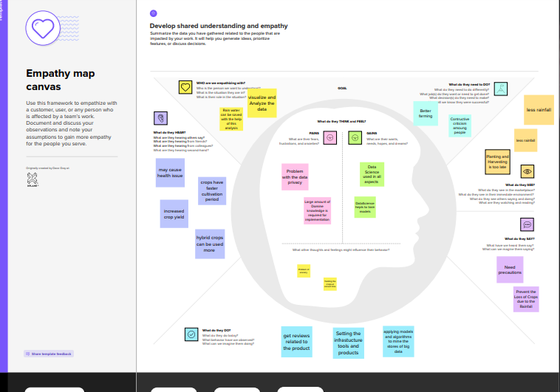

* 1. **Ideation and Brainstorming:**

